Entering Actuals Using Timesheets and Task
This document describes the process of how to use timesheets and task to enter actuals on a day to day basis.

In order for actuals to be applied to the Project Workplan (MPP), time entered in the timesheets must be imported into the Task Assignment Page on a daily basis.

STEP 1: Log into Project Web Access. http://mr2ds0024/PWA/default.aspx

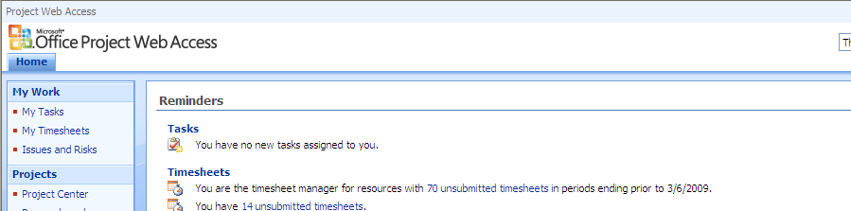

STEP 2: In the Quick Launch Task Bar, click My Timesheets. Click on appropriate Timesheet to create or open

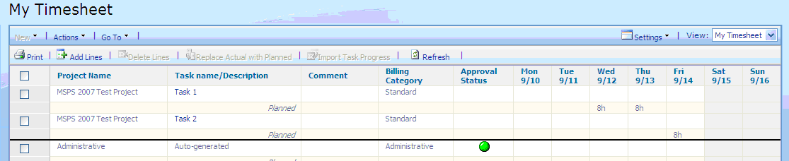

IN CASE YOU DON’T SEE a task on which you worked on:
  - Click on “Add Lines” (Read STEP3 before)
  - Select the task from List (Please DO NOT create a new task). If the task is not available In List, contact your TL (or Release Manager) as it means: the task you are looking for hasn’t been assigned to you!

STEP 3: Summary of Tasks in EPM

EPM High Level Tasks | Assigned TO: | Level | To Select
OCT09 System Test | ALL | - | Only for OCT09 Release
OCT09 Pre-/Post Release Tasks | ALL | - | Only for OCT09 Release
OCT09 Analytics Trim Webcats | Analytics | - | Only for OCT09 Release
OCT09 Regression Testing | ALL | - | Only for OCT09 Release
OCT09 Support to Markets Operations | ALL | - | Only for OCT09 Release
OCT09 Work on MIDC Projects | ALL | - | Only for OCT09 Release
OCT09 On-Boarding Tasks (NO CR) | ALL | - | Only for OCT09 Release
OCT09 - PENDING JUN09 RELEASE Work | ALL | - | Only concerning JUN09 Release
OCT09 OTHER (Admin, Miscellaneous) | ALL | - | Only for OCT09 Release
OCT09 TRAINING | ALL | - | Only for OCT09 Release
SR Investigation & Resolution | All Sales | 1 Task per SR | Per SR #
SR Investigation & Resolution | All Data | 1 Task per SR | Per SR #
SR Investigation & Resolution | All Analytics | 1 Task per SR | Per SR #
ANALYSIS | Ad-Hoc | 1 Task per CR | Per CR #
DEVELOPMENT | Ad-Hoc | 3 tasks per CR | Per CR #
CONFIGURATION AUDIT | PCR | 1 Task per CR | Per CR #

STEP 4: Enter the actuals in hours (followed by h) or in Man Days (followed by d) on the day you worked on the selected tasks (below the Standard row).

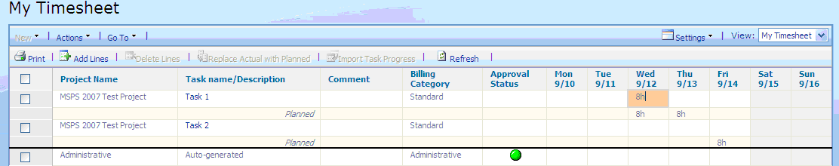

Note on Auto-generated Tasks:

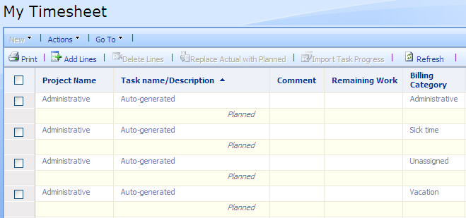 | DO NOT USE  Enter Sick Time  DO NOT USE  Enter Vacation Time

STEP 5: Click Recalculate. This will display an updated total in hours. (even if you have entered Man Days)

STEP 6: Click Save (DO NOT “Save and Submit”! TimeSheet is submitted only ONCE, at the end of the week!). If you have submitted your TimeSheet by error, click on the “Actions” Tab and select “Recall Timesheet” and SAVE again.

STEP 7: In the Quick Launch Task Bar, click My Tasks. Ensure you have “JTI-My Tasks” View selected.
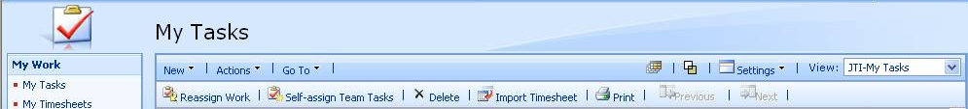

STEP 8: Import your Timesheet into My Tasks.

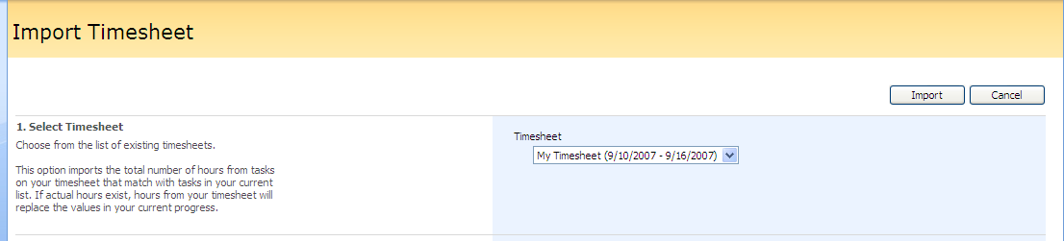

STEP 9: Click Import.

The My Tasks page will display the imported tasks ( “ ! “ in red + also, in some case, the tasks updated are not marked with a colored Line)

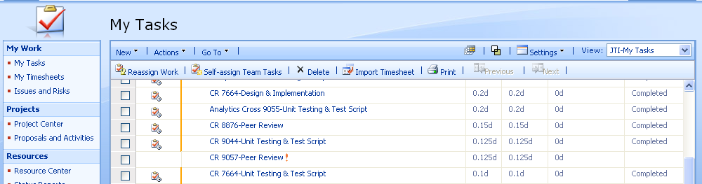

Click on Save All

STEP 10: Submit your tasks for approval [Updating the Master Plan]

- “High Level Tasks”

EPM High Level Tasks | Assigned TO: | Level | Process
 | ALL | - | 1) Select:
HIGH LEVEL TASKS AS | ALL | -
DESCRIBED ON FIRST PAGE | ALL | -
 | Analytics | - | 2) Save All 3) Submit Selected
 | ALL | - | 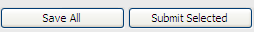
SR Investigation & Resolution | All Sales | 1 Task per SR | SEE BELOW
SR Investigation & Resolution | All Analytics | 1 Task per SR | SEE BELOW
ANALYSIS | Ad-Hoc | 1 task per CR | SEE BELOW
DEVELOPMENT | Ad-Hoc | 3 tasks per CR | SEE BELOW

- SPECIFIC CR or SR Tasks linked to “SR Investigation & Resolution” / “ANALYSIS” or “DEVELOPMENT”

Scenario 1: The task is completed, the field shows: “0d”
    - Select “Completed” in Health Field (Click somewhere else to validate)
    - Proceed as shown in above table 1) ➔ 2) ➔ 3)

Scenario 2: The task is completed, but the field shows some Values
    - Double-click on Task Name
    - Ensure that “Finish” Date is equal to “Start” Date
    - Click Recalculate
    - The remaining Work Value will automatically be set on 0h
    - Click Save
    - Select “Completed” in Health Field (Click somewhere else to validate)
    - Proceed as shown in above table 1) ➔ 2) ➔ 3)

Scenario 3: The task is not completed, but the field shows: “0d”
    - Double-click on Task Name
    - In Remaining Work, enter an estimation (h) of additional time required to complete the Task
    - Click Recalculate
    - The “Finish” Date will automatically be updated accordingly
    - Click Save
    - Proceed as shown in above table 1) ➔ 2) ➔ 3)

Scenario 4: The task is not completed, and the field shows some Values
    - Proceed as shown in above table 1) ➔ 2) ➔ 3)

Note: In case rework is needed (SRs, Bug Fix,…) it will always be possible to reselect the task in your TimeSheet and update the additional work done.

After the task assignment has been submitted for approval, the message, “Your changes have been submitted” will display.

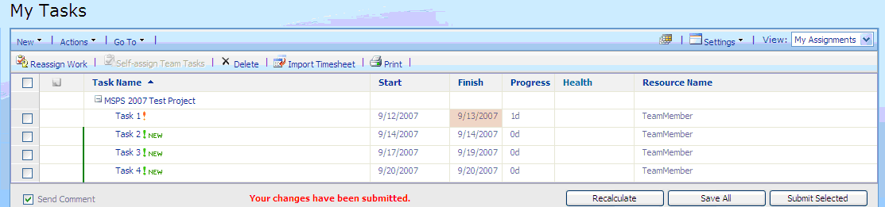

EPM Workflow (Daily basis)

